**Installing VS Code, Extensions & Setup | JavaScript Tutorial in Hindi #1**

**Welcome to the beginner's JavaScript course!**The objective of this tutorial is for you to gain familiarity with what JavaScript is, what it can do, and how it fits into a website.

**What is JavaScript?**

JavaScript, which is abbreviated as JS, is a programming language that conforms to the ECMAScript specification. It was initially created to make web pages alive. JavaScript is high-level, often just-in-time compiled, multi-paradigm. It is lightweight and most commonly used as a part of web pages, whose implementations allow client-side script to interact with the user and make dynamic pages. Using JavaScript, we can change and update both HTML and CSS. JavaScript has no link with Java programming language. It is a fully independent language with its own specification.

**What is the difference between the Client-side and Server Side?**

Client-side and server-side in the term of web development, describes where application code runs. Web developers will also refer to this distinction as the frontend vs. the backend. In web development, the client-side refers to everything in a web application displayed on the client end (end-user device). The browser interprets HTML and CSS on the client-side. Whereas, the server-side is where all the request coming from client-side is handled. The working which is performing on the server-side is not visible to the end-user. The Server-side has the business logic for dynamic webpages.

**Which IDE will we use for JavaScript?**

There are many IDE available for JavaScript like sublime text, Atom, or VS Code. IDE (stands for Integrated Development Environment) is a software application that combines all of the software developer's features and tools. An IDE normally consists of a source code editor, debugger, and build-in automation tools. It is very important to have a good IDE for software development.

For this series, we will use the VS Code. ***Visual Studio Code*** is a free and powerful source-code editor that runs on the desktop. It is made by Microsoft for Windows, Linux, and macOS. Features include support for debugging, syntax highlighting, embedded Git, snippets, and intelligent code completion. It is written in **ElectronJS**technology. Following is the guide to install the VS Code.

**Installing VS Code, Extensions & Setup:-**

Let us start the installation process. First, we are going to see the installation of VS Code. For that, search "VS Code download" on google or directly visit the URL given below:

[***https://code.visualstudio.com/download***](https://code.visualstudio.com/download)

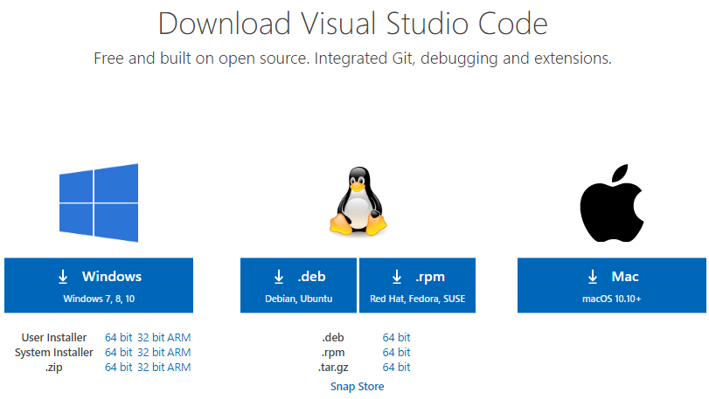

***Figure1: Virtual Studio Download***

Click on the download option. After the download is completed, open the setup and run it by saving the VS Code in the default location without changing any settings at all. Just click the next button until the "Select Additional Task" dialog box appears. Check to mark the following options.

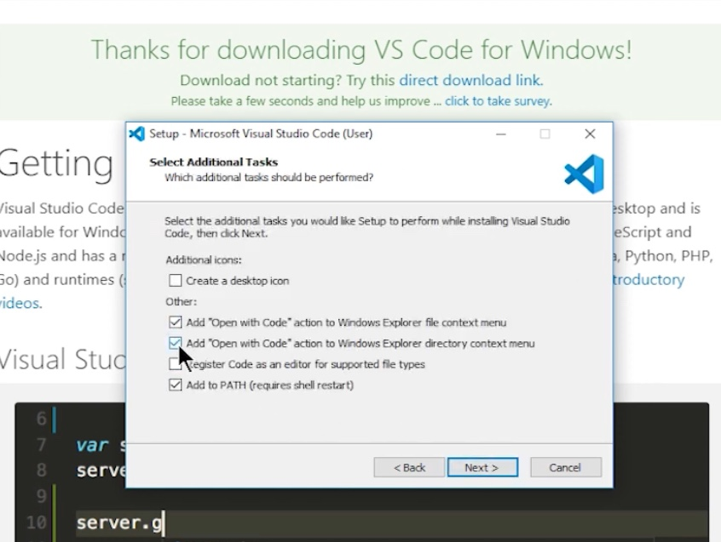

***Figure 2: Addition Task dialog box***

Then click next and install the setup. Now after the VS Code is downloaded on the system. Click on the VS Code icon. To open the folder, click on the **"Open Folder"**option on the left side of the screen or right-click on the folder and select the option **"Open with Code."**

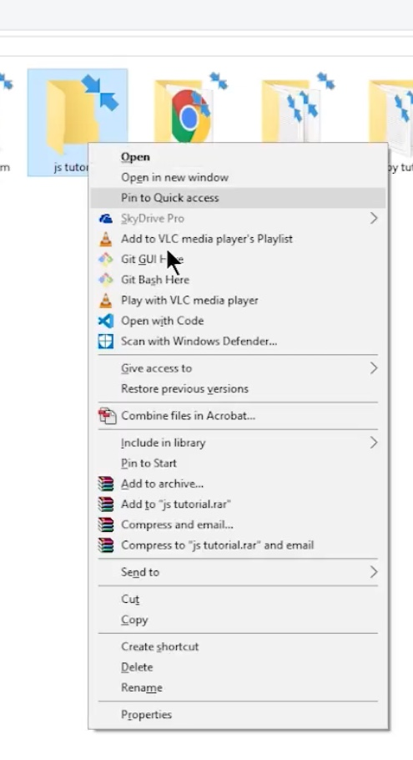

***Figure 3: Open folder with VS Code***

Now let us install the extensions that we need for JavaScript coding.

**Installing Extensions:-**

Click on the extension icon on the left of the screen or press Ctrl+Shift+X. After clicking on the extension option, write the name of the extension, and download it.

For this series, we will download "Live Server." It will Launch a local development Server with a live reload feature for static & dynamic pages.

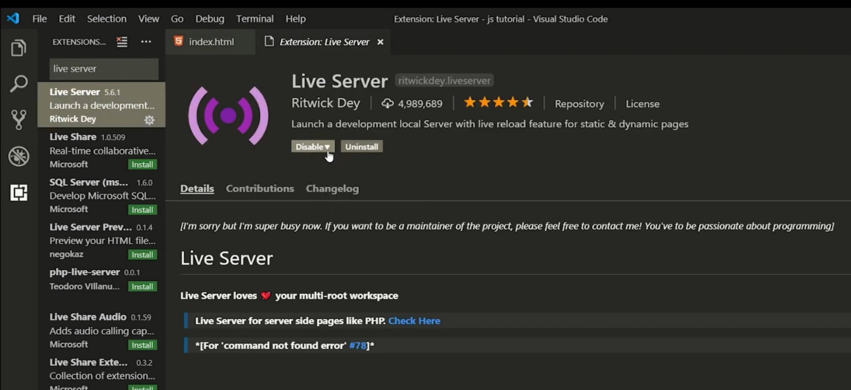

***Figure4: Live Server***

To stop the live server, click on Port at the bottom of the screen. It will dispose and then close the live server.

Another extension we have to download is "JavaScript es6 code snippet". *VS Code* comes with many built-in code snippets. The *JavaScript* ES6 *code snippets* extension adds snippets for ES6 (ECMAScript 6) syntax.

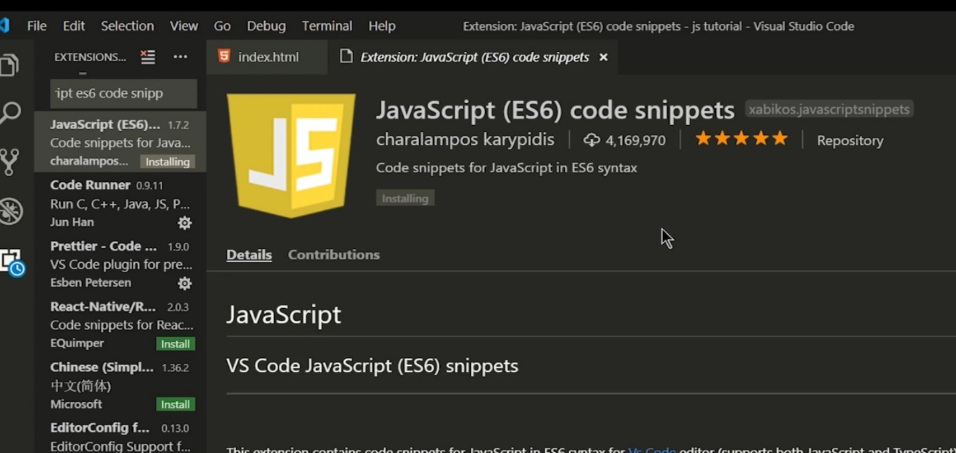

***Figure5: JavaScript ES6 Code Snippets.***

**Emmet in Visual Studio Code:-**

Emmet snippets and expansion is built right into Visual Studio Code; no extension is required. Emmet 2.0 has support for the majority of the Emmet Actions, including expanding Emmet abbreviations and snippets. When we start typing an Emmet abbreviation, we will see the abbreviation displayed in the suggestion list.

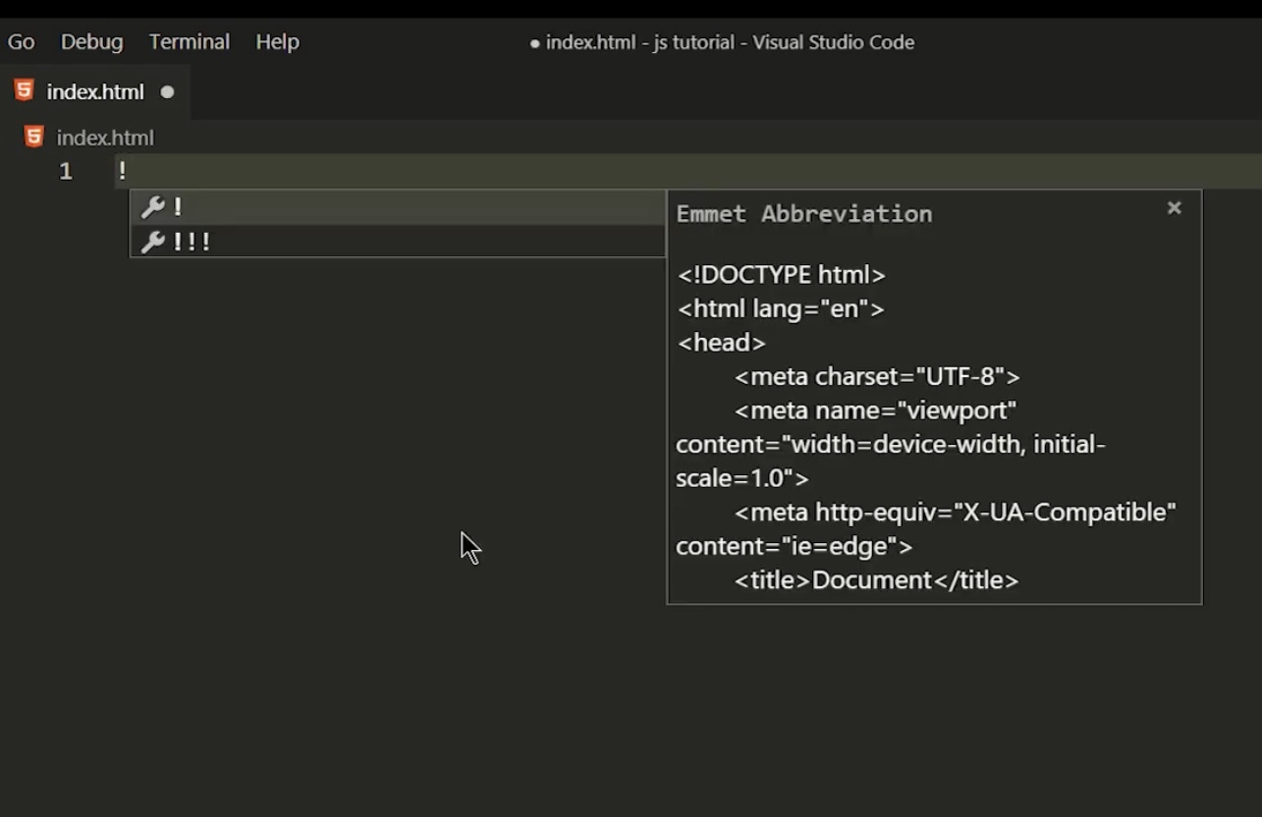

***Figure 6: Emmet Abbreviation***

**Enable Mouse Wheel zoom in VS Code:-**

To enable the zoom in/out features for text, click on the gear icon, and then click on settings. VS Code has two types of setting: User and Workspace setting. User settings will apply everywhere where we go, whereas the workspace setting is applied only to the specific folder. One way to apply the settings is to Open User Settings and edit settings.json. Add "editor.mousewheelzoom": true and then save it. Another way is to search the mouse wheel and checkmark the option. We can use the mouse wheel to zoom in or zoom out of only text in the text box.

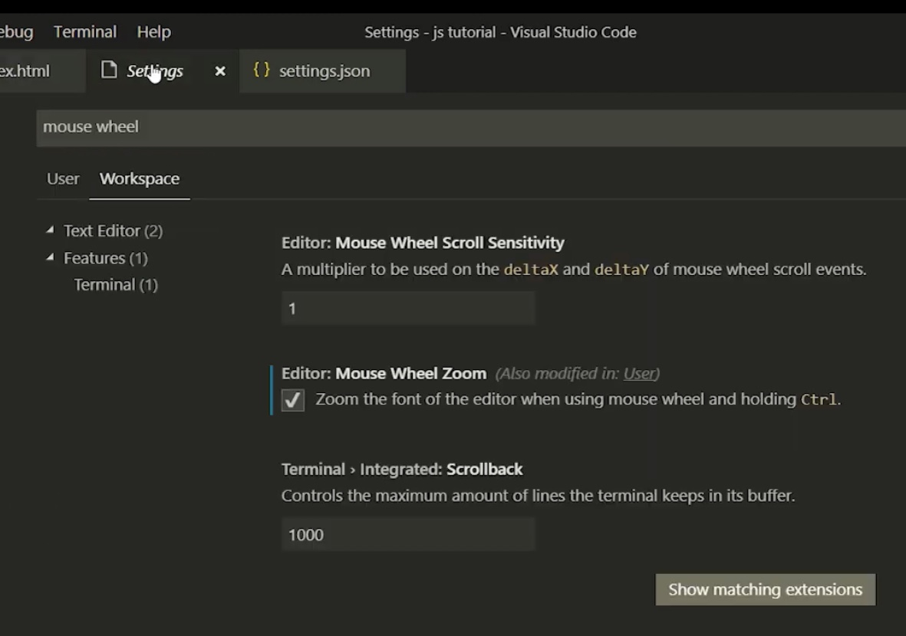

***Figure 7: Mouse wheel***

**Enable Word Wrap:-**

To enable the word wrap, follow the same instruction as mentioned for the mouse wheel and search for word wrap, and set the word wrap option to "on."

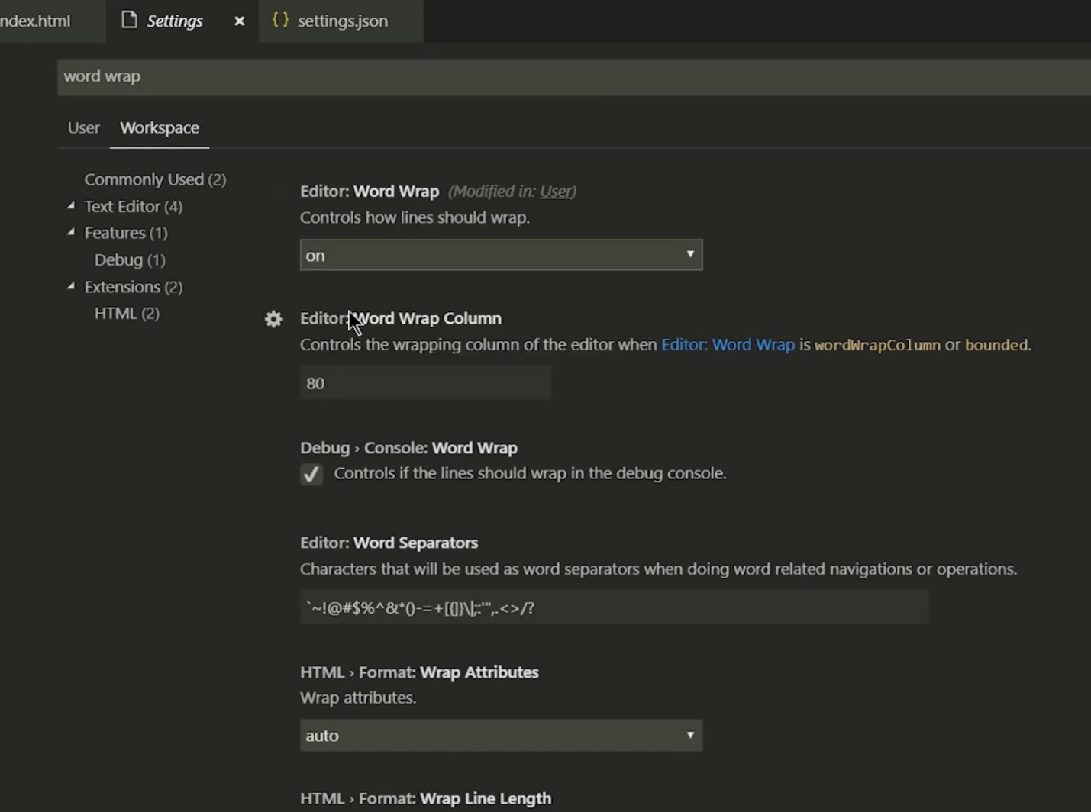

***Figure 8: Word wrap***

When we set the word wrap option to on, the JSON file will edit, and then we can use this file on any system to apply the same settings.

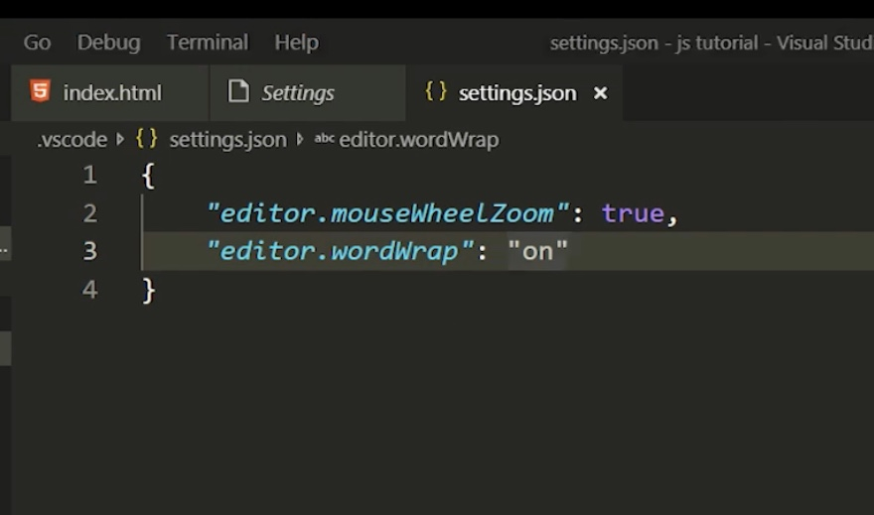

***Figure 9: JSON file***

No Source Code Associated With This Video